| **Ex No: 6**  **Date: 09/09/24** | **Autoencoder using the MNIST dataset** |
| --- | --- |

**Objective:**

To build an autoencoder that compresses MNIST images into a lower-dimensional representation and then reconstructs the original images from this compressed format.

**Descriptions:**

In this exercise, we broke the implementation down into three steps:

**Data Preparation:** MNIST images are loaded, normalized, and flattened into 784-dimensional vectors using TFDS.

**Model Architecture:**

* **Encoder:** A dense layer with 32 units (ReLU) compresses the input.
* **Decoder:** A dense layer with 784 units (sigmoid) reconstructs the images.

**Training:** The model is compiled with the Adam optimizer and binary cross-entropy loss, then trained for 50 epochs.

**Model:**

* **Encoder**: A dense layer with 32 units and ReLU activation compresses the input image to a 32-dimensional representation.
* **Decoder**: A dense layer with 784 units and sigmoid activation reconstructs the original 784-dimensional image from the compressed representation.

**Result and Analysis:**

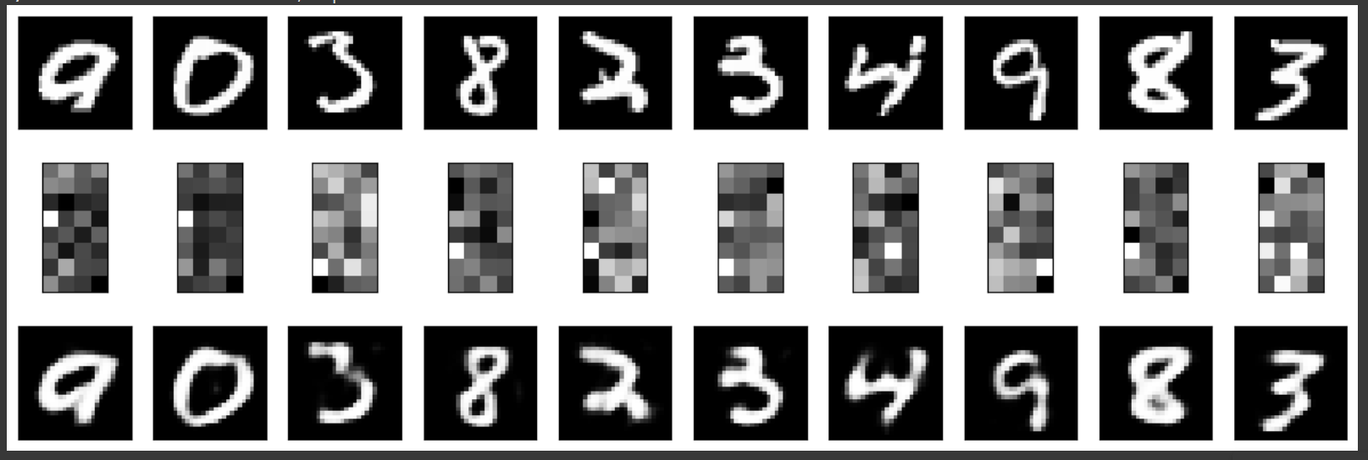

**GitHub Link:**

[**https://github.com/Gmohith7/FundamentalsofDL/blob/main/Lab%20-%206.1/Lab%20Encoder%201%20-%20Linear%20DISTRI.ipynb**](https://github.com/Gmohith7/FundamentalsofDL/blob/main/Lab%20-%206.1/Lab%20Encoder%201%20-%20Linear%20DISTRI.ipynb)